- Program ID : VI002MA1

- Display Layout
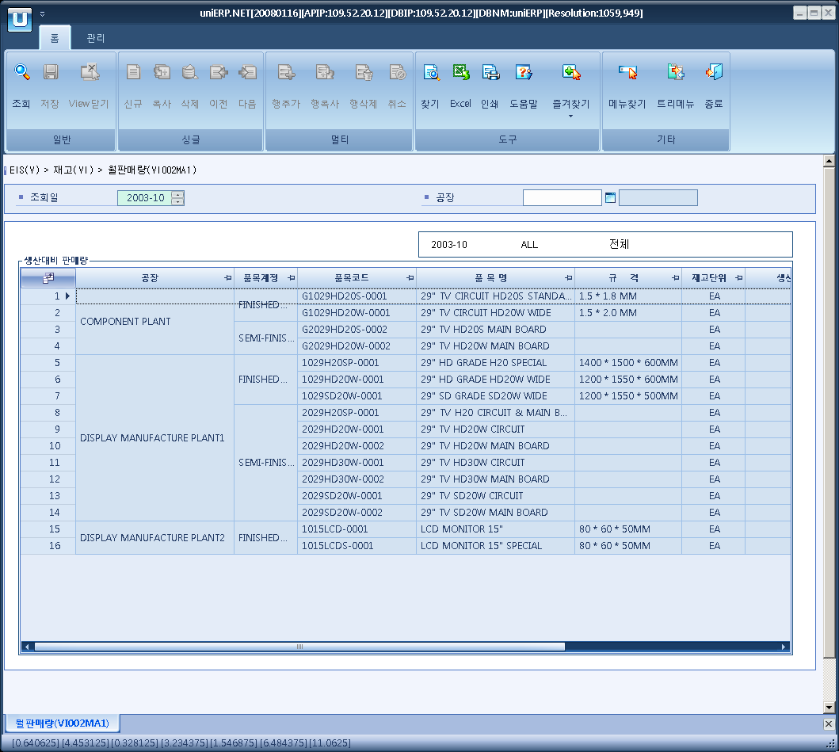

- Event flow
- Click Query button
- OnFncQuery -> DbQuery -> DataChange
- Display Unit combo change
- uniCombo1_ValueChanged -> DataChange

- SQL Statements
- Monthly sales status
SELECT I_GOODS_MOVEMENT_DETAIL.PLANT_CD, B_PLANT.PLANT_NM, B_ITEM.ITEM_ACCT, B_MINOR.MINOR_NM,
I_GOODS_MOVEMENT_DETAIL.ITEM_CD, B_ITEM.ITEM_NM, B_ITEM.SPEC, B_ITEM.BASIC_UNIT,
SUM(CASE I_GOODS_MOVEMENT_DETAIL.TRNS_TYPE WHEN 'MR' THEN I_GOODS_MOVEMENT_DETAIL.QTY ELSE 0 END),
SUM(CASE I_GOODS_MOVEMENT_DETAIL.TRNS_TYPE WHEN 'DI' THEN I_GOODS_MOVEMENT_DETAIL.QTY ELSE 0 END),
CASE SUM(CASE I_GOODS_MOVEMENT_DETAIL.TRNS_TYPE WHEN 'MR' THEN I_GOODS_MOVEMENT_DETAIL.QTY ELSE 0 END)
WHEN 0 THEN 0
ELSE SUM(CASE I_GOODS_MOVEMENT_DETAIL.TRNS_TYPE WHEN 'DI' THEN I_GOODS_MOVEMENT_DETAIL.QTY ELSE 0 END) /
SUM(CASE I_GOODS_MOVEMENT_DETAIL.TRNS_TYPE WHEN 'MR' THEN I_GOODS_MOVEMENT_DETAIL.QTY ELSE 0 END) * 100
END
FROM I_GOODS_MOVEMENT_DETAIL, B_ITEM, I_GOODS_MOVEMENT_HEADER, B_PLANT, B_MINOR
WHERE I_GOODS_MOVEMENT_HEADER.ITEM_DOCUMENT_NO = I_GOODS_MOVEMENT_DETAIL.ITEM_DOCUMENT_NO
AND I_GOODS_MOVEMENT_DETAIL.ITEM_CD = B_ITEM.ITEM_CD
AND B_ITEM.ITEM_ACCT IN ('10', '20')
AND I_GOODS_MOVEMENT_DETAIL.TRNS_TYPE IN ('MR', 'DI')
AND I_GOODS_MOVEMENT_HEADER.DOCUMENT_DT >= @strYyyymm + '01'
AND I_GOODS_MOVEMENT_HEADER.DOCUMENT_DT < DATEADD(MONTH, 1, @strYyyymm + '01')
AND I_GOODS_MOVEMENT_DETAIL.PLANT_CD LIKE @strPlantCd
AND B_PLANT.PLANT_CD = I_GOODS_MOVEMENT_DETAIL.PLANT_CD
AND B_MINOR.MAJOR_CD = 'P1001'
AND B_MINOR.MINOR_CD = B_ITEM.ITEM_ACCT
GROUP BY I_GOODS_MOVEMENT_DETAIL.PLANT_CD, B_PLANT.PLANT_NM, B_ITEM.ITEM_ACCT, B_MINOR.MINOR_NM,
I_GOODS_MOVEMENT_DETAIL.ITEM_CD, B_ITEM.ITEM_NM, B_ITEM.SPEC, B_ITEM.BASIC_UNIT
ORDER BY I_GOODS_MOVEMENT_DETAIL.PLANT_CD, B_ITEM.ITEM_ACCT, I_GOODS_MOVEMENT_DETAIL.ITEM_CD

